Spike: Spike 7
Title: Non-Blocking Loop

Author: Rachel McQueenie 696737x

Goals / deliverables:
- Create a console program that implements the “Zorkish” game using a non-blocking game
- loop. The loop must execute continuously, only processing input when it occurs, and only
- providing output when necessary.

Technologies, Tools, and Resources used:
- Windows 7 / 8
- Visual Studio Professional 2012 / Ultimate 2012
- Spike 6

Tasks undertaken:
- Follow and complete Spike 6
- Include the “conio.h” library
- Use the “kbhit()” function from the conio library to check if the keyboard has been pressed. If it has, call the Input method. Otherwise, just continue running Update and Render.
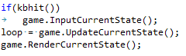

- Add a variable to keep track of the number of times the application has looped
- Whenever the application loops, add '1' to the tick counter
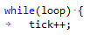
- For every 5000 loops, print 'ticking along' to demonstrate that the application is running without user input
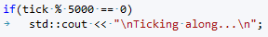
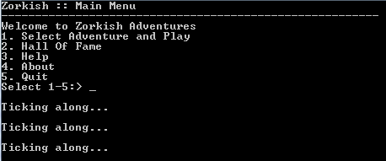
- Congratulations, you now have a non-blocking game loop!
What we found out:
The non-blocking game loop is a simple and useful tool in game programming as it allows the application to run smoothly regardless of user input. This is useful for video games as several computations need to be made around user, such as calculating enemy movements and AI decisions. This, however, would not be a good option for certain other applications, such as a word processors where nothing needs to be done until the user inputs something.

Recommendations:
Even though this application continues to run without keyboard input, when it does detect input it will use std::cin to get the contents. This command will pause the application similarly to the blocking loop. So although this application met the expectations of the Spike, ideally it would continue to run while the user inputs from the keyboard, not just around it as it currently does.

Also, the “conio.h” library is only compatible with Windows operating systems, so if you wish to make this application cross platform then you would need to find another means of detecting whether the keyboard has been pressed.

Finally, the repeated loops will continually render the same thing, even if there has been no change to the game's state. To get around this, you may want to add a 'render' variable to your classes which will check if the screen has been rendered before or not, and only render if it hasn't been rendered before or if an update has been made. Alternatively you could also clear the screen after every loop and re-render everything, but that will make it difficult to display the 'ticking along.'

